**Developer Guide**

**Architecture overview**

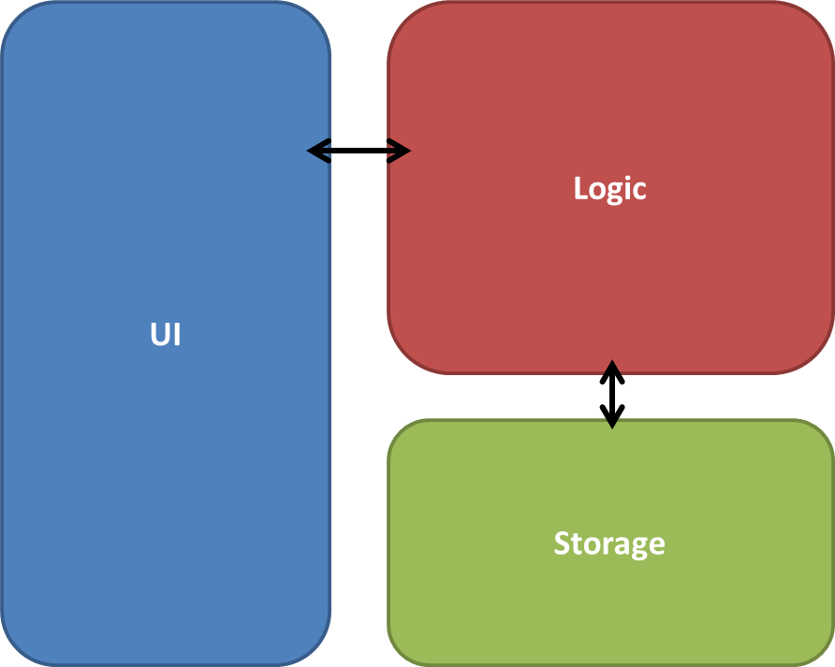*Epiphany* is written in java. Given above is a high level overview of its main components.

* **UI**: The UI seen by users is written using the JavaFX library.
* **Logic**: The logic handles all the actual execution of the application.
* **Storage**: The storage component reads and writes to a single .txt file which acts as the database for the application.

The diagram below shows how the code is organized into inside each component and dependencies among them.

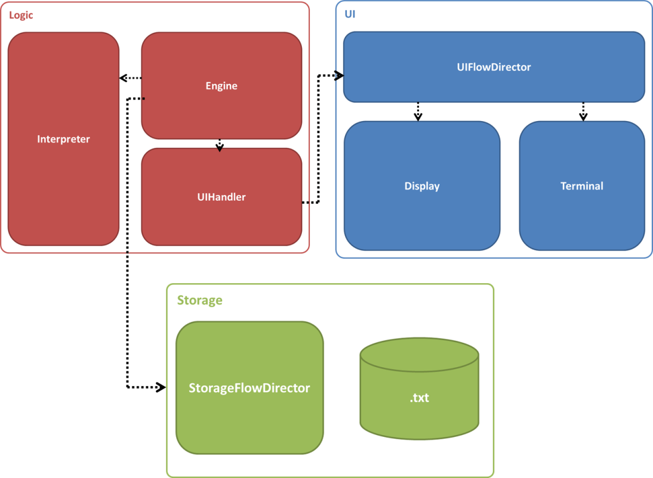

**Note:** In this architecture Storage-UI-Logic represent an application of Model-View-Controller pattern

**Logic**

The diagram below shows the class diagram of the Logic component

